2026-27 FAFSA Frequently Asked Questions (FAQs)

Last updated: December 2, 2025

General

Q: When did the 2026-27 Free Application for Federal Student Aid (FAFSA) open?
A: The form opened on September 24, 2025, for all students (one week earlier than expected).

Q: What changes were contained in the reconciliation bill passed in July 2025 that have an impact on the FAFSA form/process/formula?
A: There were a few changes that become effective on July 1, 2026, that will have an impact on the 2026-27 FAFSA and Student Aid Index (SAI) formula. These changes include:
- The asset exemption for family farms and small businesses will be reinstated. This definition has been expanded to include family-owned commercial fisheries.
- Foreign income will be included in the adjusted gross income (AGI) used to calculate Pell Grant eligibility-this will become an automated process in lieu of aid administrators having to do a manual review of FAFSAs that contained foreign income.
Two items that impact Pell Grant eligibility include:
- For those who may have been eligible for a minimum Pell Grant based on the Poverty Tables: Students will receive a Pell Grant if their calculated SAI exceeds twice the maximum Pell Grant for that year. We do not yet have a max Pell amount for 2026-27.
- Students who receive grants and/or scholarships from non-federal sources that cover the cost of attendance will not be eligible to receive a Pell Grant during the terms covered.

Q: Will the 2026-27 FAFSA still contain the Parent Wizard tool inside the form to help determine which parent(s) should be reported on the FAFSA?
A: No. The tool will remain available on studentaid.gov and can be found here.

Q: What will the contributor process look like for a dependent student with parents who filed taxes jointly or an independent student who filed taxes jointly with their spouse?
A: A dependent student whose parents are married and filed a joint IRS tax form with their current spouse will only need to submit data for one parent. New this cycle, the parent must also provide their spouse’s date of birth as it is used in the SAI calculation. To identify when the parent left the parent spouse date of birth blank, the FPS added a new edit that will set record reject code 69 and comment code 330 on ISIRs. To resolve this reject, the Parents Spouse or Partner date of birth must be submitted as a correction. The FAA will be able to provide the Parent Spouse or Partner’s date of birth using the FAFSA Partner Portal or by using Electronic Data Exchange corrections. The student can provide a correction online or using the paper FAFSA Submission Summary.

Q: FSA has modified the contributor invite process. What changes have been made to simplify this process?
A: According to an Electronic Announcement, students completing a 2026–27 FAFSA will be able to invite a parent or spouse as a contributor simply by entering their email - instead of asking students for a contributor’s personally identifiable information - which will generate a unique, non-case sensitive code. The code will be sent to the parent or spouse by email. The parent or spouse will be directed to accept the invite by entering the code on an “Accept an Invite” page that can be accessed by the email or StudentAid.gov once they are logged in.

The US Department of Education (ED) expects this update to ease the process for users and reduce errors associated with matching contributors to their accounts based on identifying information.

Please note that the simplified contributor invite process will be available to students who invite a contributor, or parents who invite a spouse, to complete a 2026–27 form. If a contributor begins a FAFSA on behalf of a student, they will use the existing process to invite the student to the form. In that case, the student must have a StudentAid.gov account and will be linked immediately to the application upon being invited.

The email address does not have to match the email that the contributor used to establish their StudentAid.gov account (FSA ID). However, the code is going to be sent to the email entered so it will be critical to retrieve that code from that email prior to the contributor logging in and accepting the invite to complete the form.

If a parent contributor starts the FAFSA, the process will remain as it currently is with the parent having to provide a significant amount of demographic information about the student who will receive an invitation to finish the form. There is no new code generated for this process.

Q: What changes were made to the questions regarding the student’s gender?
A: To align with Executive Order 14168, the following changes were made: FSA changed the question, “What is the student’s gender?” to read, “What is the student’s sex?” FSA deleted the answer options “Nonbinary” and “Prefer not to answer” leaving the “Male” and “Female” response options. This is a required field, and the student cannot leave it blank.

This change was initially made in February 2025 for the 2025-26 FAFSA and will remain this way until ED is ordered to make any changes.

StudentAid.gov Accounts/FSA ID

Q: FSA has shared that there are changes coming to the process for setting up a StudentAid.gov account. What will the changes entail?
A: Effective December 7, 2025, several changes will take place when a person sets up a StudentAid.gov for the first time. Here is a summary of the expected changes:
- Users will face only six pages and 12 required fields (instead of 23). Challenge questions, backup code copy confirmation, and duplicate fields have been removed.
- Users will choose their preferred language - English or Spanish - at the first step. Previously, they picked a language at step four and had to restart the flow.
- Users can copy and paste data from a password manager. No more risk of entering incorrect data by hand.
- Users can reuse phone numbers, previously owned by other people. If they have the number and respond when receiving the verification text, that number will be associated with their account.

FSA is currently working on updating resources that will contain the updated process. NCAN will share those as soon as they are available. Current accounts will retain all the fields required when the account was set up. Nothing is being deleted at this time.

Q: What changes have been made to the identity verification process for those creating accounts that have a Social Security number (SSN)?
A: Effective August 3, 2025, the process for verifying identity for those with a SSN has been modified. When a person sets up their account, their identity will be instantly verified with the Social Security Administration. The person will see a screen confirming that their identity has been verified. That person can go directly to the FAFSA and have full functionality in the form-they can sign, transfer data from the IRS, etc. There is no longer a three-to-five day waiting period for verification. If the person’s identity is not matched, they will be prompted to check the information entered to make sure there are no errors. If they find an error, they should correct it and the system will attempt to verify them again. If the person makes too many attempts and is not verified, their account will be “paused” and they need to contact the FSA Information Center to request assistance.

The process for those setting up accounts who do not have a social security number remains the same as it has been for the last two cycles.

Below are examples of the messaging that a person with a SSN will see in each instance:

Information matches with Social Security Administration:

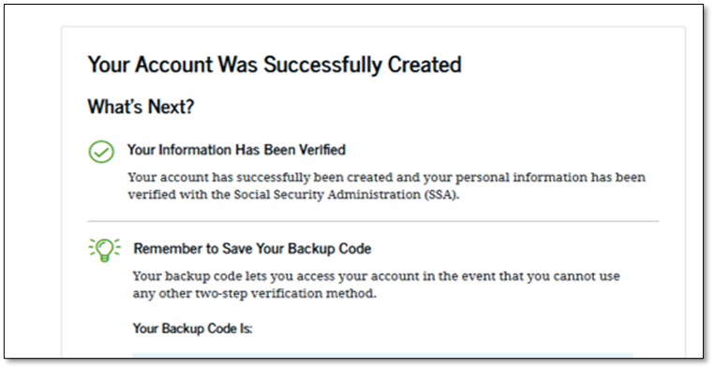

Information DOES NOT match with Social Security Administration:

